UNIT 3

LEVEL 2

**HTML Tables**

1. Create a web page to display the table as follows

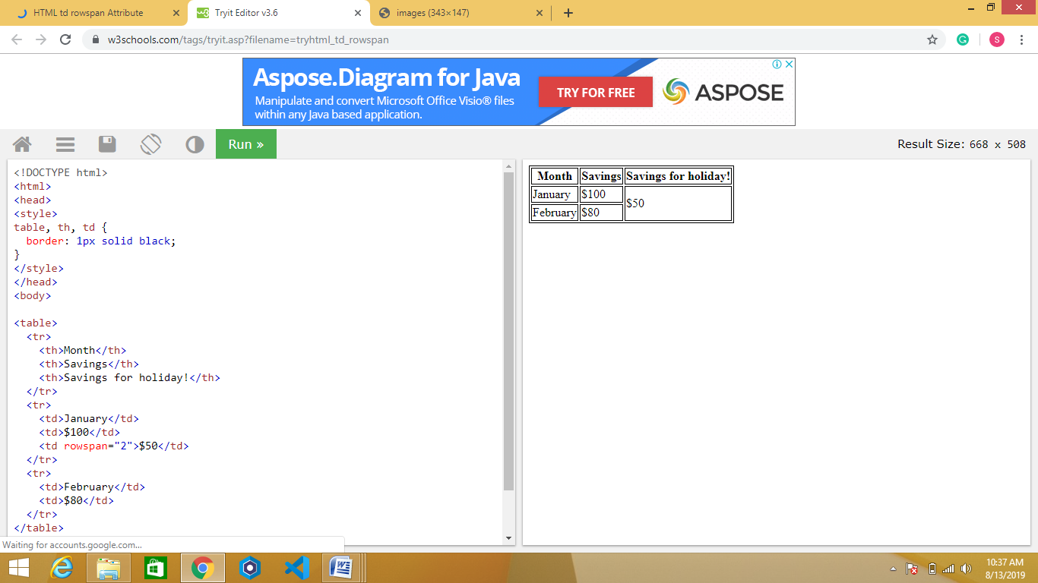

1. Create a web page to display the table

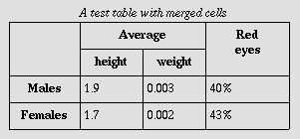

1. Create a webpage to display the table as follows.

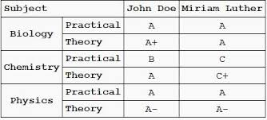

1. Create a web page to display table as follows

